1.8 Hyperbolic Trigonometric Functions

Motivation: The trigonometric functions work well when we are trying to do trigonometry on a plane (intuitively a plane is a flat, infinite two dimensional object).

However, it doesn’t always make sense to do trigonometry on the plane. For example, the earth is roughly a sphere and trigonometry on a sphere is different than trigonometry on a plane. Another example where trigonometry will be different is if we are on a hyperbolic plane (the instructor will show an example of what a hyperbolic plane might look like).

In hyperbolic trigonometry, for any real number t, the point ( is read “hyperbolic cosine of t” and is read “hyperbolic sine of t”) lies on the right branch of the hyperbola and is such that the signed area of the “sector” formed by the segment from the origin to (1,0), the segment from the origin to , and the arc of the hyperbola is: . The image below from Wikipedia illustrates this idea:
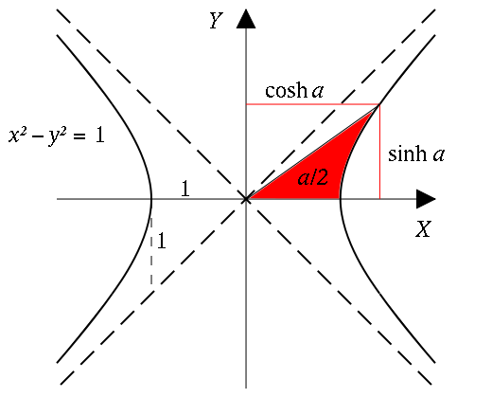

It can be proven using the definition above and ideas from the start of Chapter 2 that for any real number x, and .

Note: This result makes sense since the x coordinates are all positive on the right branch of the hyperbola above and y values may be both positive and negative.

This leads to the following definitions.
Definitions: We define six hyperbolic trig functions.
Pronounced "sinch”

Pronounced "cosh”

Example 1: Evaluate each of the following using the definition.

Graphs of hyperbolic functions:
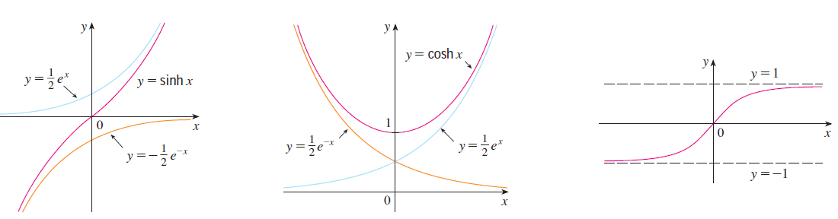

Theorem: We have the following identities for all real x that are in the domain of the functions involved in each identity:

Example 2: Show that .

Example 3: Find and .

&

Theorem: We have the following derivatives for our six hyperbolic trig. functions.

Applications
Hyperbolic functions arise when a homogeneous cable is suspended between two points.

Catenary Curve  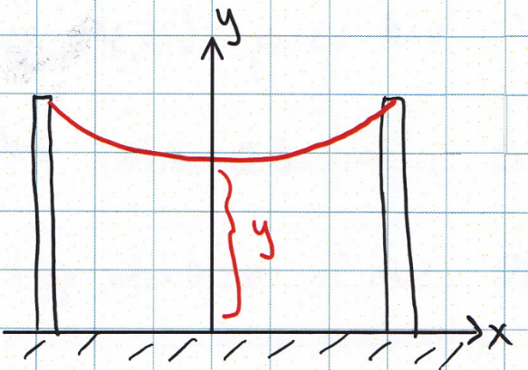 | (where a and c are constants driven by the type of cable and the distance between the poles.)

Example 4: Suppose a cable is attached between two poles which stand 30ft apart and can be modelled by the function . Determine the exact length of the cable from .

is continuous on . Therefore the arc length of the cable is given by:

. Since is always positive we can drop the absolute value bars. Therefore,

Example 5: Consider the region bounded by the curves & from .

- Determine the exact value of the area of this region.
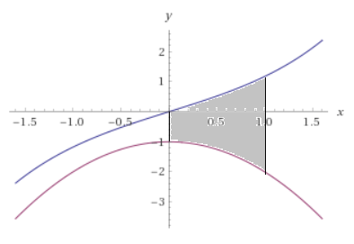
- Set up, but do not evaluate, and integral which represents the volume when this region is revolved around the y-axis.

This question is simple to answer if we do an integral with respect to x. This will require the use of cylindrical shells.

OR

If we choose to use washers we have to calculate integrals with respect to y. We would obtain.

- Suppose you rotate the curve on about the x-axis and attempt to determine the surface area of the resulting solid. Why does the integral not represent this surface area?
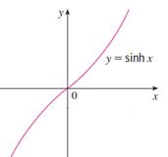

The reason that this integral does not compute the desired surface area is because the function is negative for and therefore it does not met the conditions for the use of the surface area integral.

